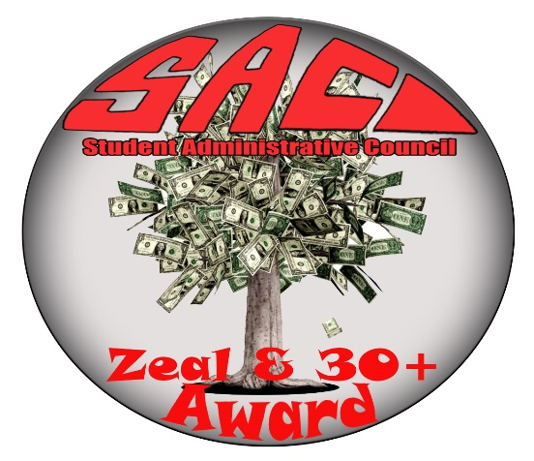

SAC ZEAL RECOGNITION AWARD APPLICATION
Applicant displays school spirit through participating in SAC activities, expressing a SLC positive attitude, helps SAC behind the scenes, participating in SLAC, making banners, advertising events or a board member. Grades must be 65% or over as confirmed by your program coordinator.
NAME: _______________________________________________________
EMAIL ADDRESS: _______________________________________________
PROGRAM: ____________________________________________________
WRITE WHY YOU BELIEVE YOU DESERVE TO RECEIVE THIS AWARD WIT THE CONTRIBUTIONS YOU GAVE TO SAC
_______________________________________________________________________________________________________________________________________________________________________________________________________________________________________________________________________________________________________________________________________________________________________________________________________________________________________________________________________________________________________________________________________________________________________________________________________________________________________________________________________________________________________________________________________________________________________________________________________________________________________________________________________________________________________________________________________________________________________
DATE: _____________________________________________

Deadline is March 15, 2019

